**Christ Chapel Academy Summer Camp 2025**

Preschool K3 and K4

June 2 – July 25, 2025

Welcome to Christ Chapel Academy’s Preschool Summer Camp! There are a wide variety of activities planned for your child this summer. This year Mrs. Susan Sexton will be our K3 camp teacher and Mrs. Angie Wilkins will be our K4 camp teacher.

**REGISTRATION FEE:**

If paid by May 9, 2025 - $50.00

If paid after May 9, 2025 - $150.00

Preschool 3 and 4 Camp Price - $350.00 per week

**NOTE SUMMER HOURS - Camp Hours: 6:30 am - 6:30 pm**

Our activities will be centered around a weekly theme and Bible story. Your child will learn as they play, while reviewing concepts and skills to keep them ready for the coming school year. Art, Cooking, Science, Math and Literacy will be woven into daily lessons. Preschool Campers will have access to outdoor play as well as gross motor activities.

Lunch and snacks are included with weekly summer camp registration. Lunch menus are posted at christchapelacademy.org under the Summer Camp tab on the home page.

There are a few basic requirements for summer camp. We appreciate your help with this so that camp will be fun for all. **Labeling personal items** will help identify each child’s items. **Sunscreen MUST be applied before a child comes to summer camp. Summer camp workers are not permitted to apply sunscreen on the children.**

**Bring with you:**

* 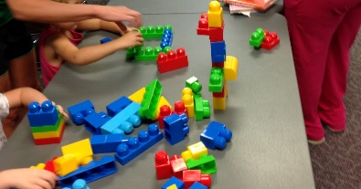Spill-proof WATER BOTTLE
* A backpack to store items. Please no roller backpacks.
* Change of clothes (stored in a zip lock bag)
* Be ready to learn, be safe, and have fun!

**Wear:**

* Closed toed, rubber soled shoes. No open toe, backless shoes, Crocs, or flip flops. This is a must in order to keep your child safe, especially during outdoor activities.
* T-shirts must have sleeves, no spaghetti straps, tank tops or halter tops.
* Short length is to be a modest length, at least to the fingertips.

**Toys**

* Toys brought in from home are only permitted for specific class activities. The teachers will notify you in newsletters when these items can be brought in.



It is going to be a great summer! Please contact the school office at 703-670-3822 X142 with any questions or concerns that you may have.

We look forward to having a fun-filled summer at CCA Summer Camp.